**Dual booting**

Greetings, developers.

I’m certain the heading gives a lucid idea of the topic I’ll be elaborating on today.

Today we will briefly discuss about Dual booting , its uses and how it works , so I often come across a variety of people who do not know about dual boot , so here is some breif information on what it is , and how it is done.

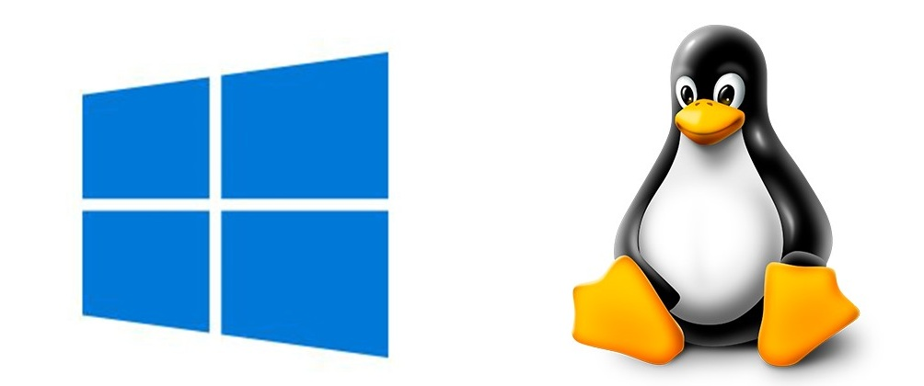

**What is Dual booting?**

Dual booting is basically having two different operating systems installed on same computer , it can also be called multi booting if two or more operating systems are installed. When we dual boot we can also select which operating system to boot in. It can be done by using a program called bootloader which is written in MBR(Master Boot Record) of the computer. Most operating systems comes pre-installed with one bootloader. For example windows uses windows boot loader , whereas linux uses GRUB or GRUB 2 and likewise apple uses its own bootcamp.

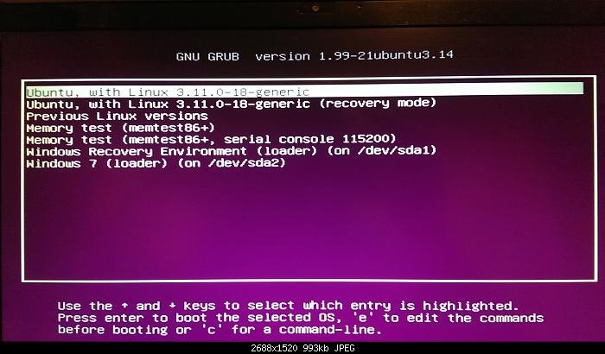

GRUB

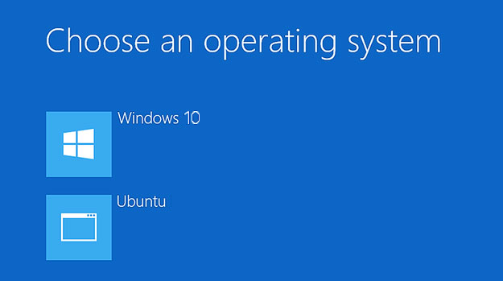

Windows Bootloader

**What is the use of dual booting?**

Dual booting is mostly used by cross-platform developers , OS enthusiast and also by people who want to enjoy seamless developing and coding by using linux and also want vast application support like windows. Some people also use it for testing compatibility , testing new systems.

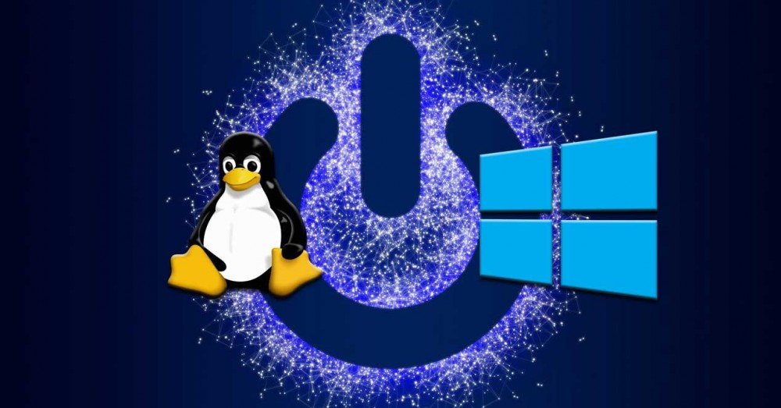

One of the best benefit of dual boot who love their valuable data stored in computer is data retrieval , even if your one OS fails , you can retrieve your data using the other distro

*Now everyone must be wondering dual boot is so efficient, so are there any disadvantages? , let us see.*

**Disadvantages of dual booting**

Dual-booting where has many advantages , it also have some cons too. It may make your computer unstable , and also cause data loss if distro or bootloader is not configured properly.

It reduces disk size for windows user because linux partition cannot be accessed from windows , where as vice versa is possible.

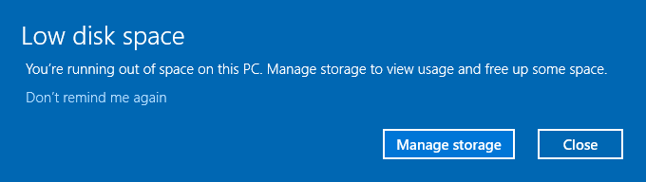

Sometimes linux updates may introduce few issues , windows updates can be literally destructive because when we run windows updates , it rewrites MBR(Master Boot Records) , leaving us with missing boot files for linux partitions , hence causing dual boot/GRUB loader to fail.

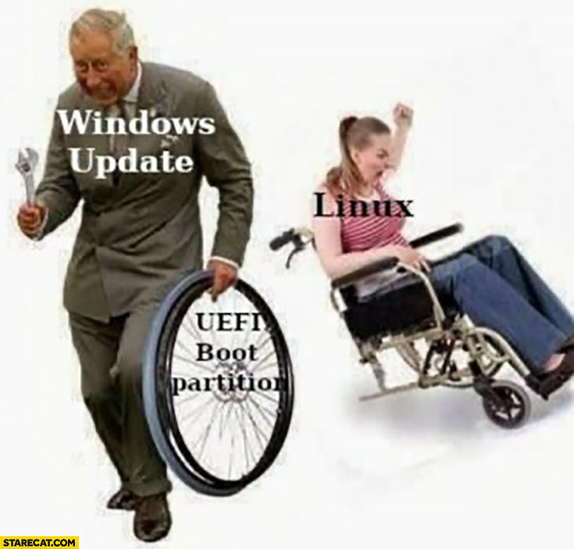

Last but not least , it also leads to wastage of space , like installing two same apps in different OS is wastage of hard drive space.

Harmanjot Singh